HOTEL RESERVATION SYSTEM

CONTENTS

SERIAL NO. | TOPIC | PAGE NO.
1 | The Project | 3
2 | The Problem | 3
3 | Objectives | 3
4 | Preliminary Idea | 3
5 | Feasibility Study | 3
6 | Requirement analysis and specification | 4
7 | Entity relationship diagram | 4
8 | Database design | 6
9 | Context diagram | 8
10 | Data flow diagram | 9
11 | Code snippets | 10
12 | Conclusion | 21

The Project:

ABC Hotel Reservation System.

The Problem:

ABC Hotel is planning to automate its reservation system online. ABC Hotel has with AC and NON-AC rooms. In that, some are 2 bedrooms and some are 3 bedrooms. Hotel manager should have a facility to do the following in the application.

1. Add rooms which includes the availability (vacant or occupied) of each room
2. View all rooms in the hotel

While customer calls in to check the availability of a room, Hotel manager will get the requirements of customer in terms of 2 or 3 bedrooms, AC/NONAC and accordingly check whether the room is available.

If available, Hotel manager collects the customer name and address and allocate him a room number. Hotel manager should be able to view all occupied rooms with customer details.

Objectives:

The following are the objectives of the Hotel Reservation System are as follows :

- Customers can reserve rooms in the hotel online.
- Hotel manager can find out whether a room is available or not and convey this information to the customer.
- Hotel manager can quickly find out rooms according to the needs of the customer.
- Hotel manager can record the details of the customer with a reservation in the hotel and view the same when needed.
- Hotel manager can add rooms to the inventory.

Preliminary Ideas:

In Hotel Reservation system we have taken some assumptions which are as follows:
- The room numbers are allocated to the customers are in serial order, the customer cannot choose his/her preferred room number.
- There is no provision for cancellation of reservation.
- There are a finite number of N rooms in the hotel, and out that N rooms N’ rooms are currently being used by customers, rest of the M = N – N’ rooms are not used. The hotel manager can add rooms for usage form M left over rooms when the currently used N rooms are all reserved.
- Hotel manager can view two lists , Firstly the list of all empty rooms, Secondly the list of occupied rooms.

The Feasibility Study:

As the initial investigation is completed, it leads to a more detailed investigation of the system. The conclusions of the initial study become the input for the detailed study. We can also refer to the feasibility study as the detailed study or detailed investigation. Feasibility study is called like because as in the first phase, we just check briefly about the problems related to the old system, & the need of the new system. So, in this phase, that initial survey is further expanded to a more detailed feasibility study.

The tasks performed during this phase were as follows:

(a) The user’s demonstrable needs are fulfilled.
(b) The availability of resources was being checked.
(c) The estimation required for the resources were achieved.
(d) The impact of the system on the organization has been check by placing a model in it.

Requirement Analysis and Specification:

Objective To Be Fulfilled:

(a) Development of software in the given time.
(b) To create an effective and efficient application.

User Requirements:

(a) The application should provide a user friendly environment.
(b) The application should be easily understandable and reliable.
(c) The application should fulfill all essential facilities.
(d) The software being built must provide platform independent application.

Requirement Determination Techniques & System Analysis Method:

(a) User communication
(b) Team discussion
(c) Analysis of existing system
(d) Study of old projects and records.

Design – High level and Low level

Entity Relationship Diagram:

Conceptual modeling is a very important part in designing a proper database application. Here the term database application refers to a software product that has a central database containing data and some associated programs that operate on the data in the database to give desired results of our queries. In the Hotel Reservation System problem we are representing conceptual model of the problem by the help of ER data modeling. An entity-relationship (ER) diagram is a specialized graphical representation that illustrates the interrelationships between entities in a database. ER diagrams often use symbols to represent three different types of information. Boxes are commonly used to represent entities. Diamonds are normally used to represent relationships and ovals are used to represent attributes.

For our database application consider a HOTEL RESERVATION database that keeps track of the rooms in the hotel taking care of the type of the room (ac/non-ac), number of beds in the room (i.e. 2 or 3 bedrooms) , and most importantly this system keeps track which of these rooms are occupied by customers, or are yet not occupied but are reserved in advance by a customer, or it is available for booking. In addition to that our database also maintains the date when a customer checks in into the hotel and when he checks out of the hotel. Our HOTEL RESERVATION database also maintains the details of every customer that stays in the hotel, namely the customer’s Name and Address.

In our HOTEL RESERVATION system we have three entities: ROOMS, RESERVATION and CUSTOMER.

- ROOMS: This entity represents each and every room in the hotel. It keeps the specific details about each room in the hotel, such as the room number, whether it is ac or non-ac, and how many beds does the room have and whether the room is already reserved. Thus the specific attributes of the ROOM entity are [ROOM_NO], [AC/NONAC],[NO_OF_BEDS],[STATUS].

- RESERVATION: For every room occupied by a customer, this entity contains one record. This entity keeps the date on which the room was occupied by the customer, the date on which the customer will leave the room or has left the room (which ever applies) , the corresponding room number and the reservation id. Thus this entity basically gives the snapshot of the hotel’s reservations. The specific attributes are [DT_OF_CHECKIN], [DT_OF_CHECKOUT],[RS_ID],[ROOM].

- CUSTOMER: This entity simply maintains the details about every customer in the hotel. It keeps the name, address and the room number where the customer will stay or has stayed in the past. The specific attributes are [CUST_ID],[NAME],[ADDRESS].

Now these three entities are related to each other by two relationships: TAKEN and MAKES,

- TAKEN: The entities ROOM and RESERVATION are related by the TAKEN relationship. We know that a customer reserves room in the hotel, so we say a room is temporarily taken by the customer. Thus the relationship taken between ROOM and RESERVATION is a 1:1 relationship, as there can only be 1 room in one reservation and no single room can have multiple reservations at the same time.

- MAKES: The entities CUSTOMER and RESERVATION are related by the MAKES relationship. In the HOTEL RESERVATION system if a customer wants to book a room, he/she has to reserve the room at advance, thus we say that the customer makes reservation at the hotel. Again a customer may want to reserve several rooms according to his needs, so in our HOTEL RESERVATION system we have also kept the provision for that facility. The relation MAKES is a 1:M relation between CUSTOMER and RESERVATION , as a single customer can make multiple reservations comprising of different rooms at different reservations but one reservation can never be made by multiple customers.

Entity Relationship Diagram:

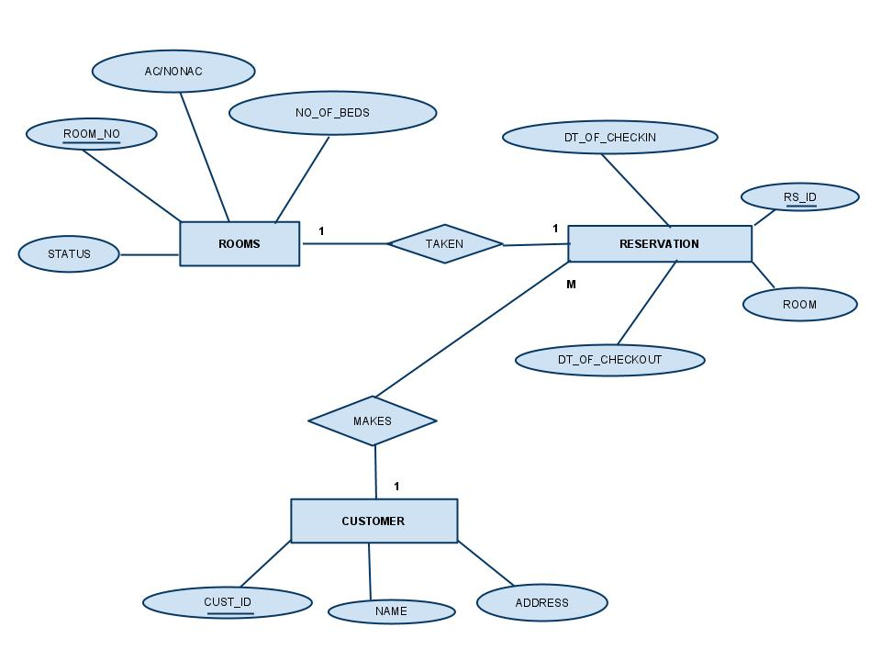

DATABASE DESIGN:

Relational schamas and functional dependancies :

- RESERVATION(RS_ID , DT_OF_CHECKIN, DT_OF_CHECKOUT , ROOM_NO, CUST_ID)

This table consists of the reservation id [RS_ID] , date of checking-in [DT_OF_CHECKIN] , date of checking-out [DT_OF_CHECKOUT] and [CUST_ID]. This table maintains data of the reservations made by the customers made on daily basis. Here reservation id , [RS_ID] is the primary key.

This table has the functional dependency:

- RS_ID → {DT_OF_CHECKIN,DT_OF_CHECKOUT,ROOM_NO}

In the above functional dependency [DT_OF_CHECKIN], [DT_OF_CHECKOUT] , [ROOM_NO] are dependent on the [RS_ID].

- RS_ID → { CUST_ID }

Customer id is dependent on the reservation id as a single customer can make a single reservation.

- CUSTOMER( CUST_ID , NAME , ADDRESS)

This table maintains the details about the customers of the hotel i.e. the customer id, name of the customer, address of the customer and reservation id. Reservation id is kept in this table so that we can find the reservation details about each customer by joining the CUSTOMER table and RESERVATION table. Here customer id, [CUST_ID] is the primary key.

This table has two functional dependencies:

- CUST_ID → {NAME,ADDRESS}

Name and address of the customer depends on the customer id.

- ROOMS( ROOM_NO , AC/NONAC , NO_OF_BEDS , STATUS )

This table maintains the list of the rooms in the hotel along with the details of the rooms like 2 bedrooms or 3 bedrooms, AC or NON-AC and the room number. Here room number [ROOM_NO] is the primary key. The status of the room depicts whether the room is reserved or is non-reserved.

This table has the following functional dependency:
ROOM_NO → {AC/NONAC, NO_OF_BEDS}
All the attributes of ROOMS are dependent on the primary key.

CONTEXT DIAGRAM

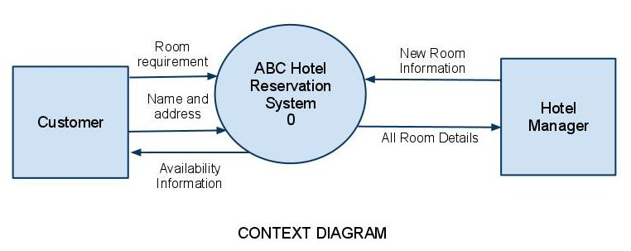

The Context diagram represents the entire system as a single module. The data values that are given to the system comprises of two types. First of all the new available rooms may be added to the system which the hotel manager does as and when the rooms are vacant. Secondly, a customer may call in to check availability of a room. The hotel manager then gets the room requirements from the customer and checks if such rooms are available. If the rooms are available then the customer’s name and address are taken and a room is allotted in his name. If rooms are not available the customer is informed of it. Apart from this the system also shows the details of all rooms present in the database.

DATA FLOW DIAGRAM

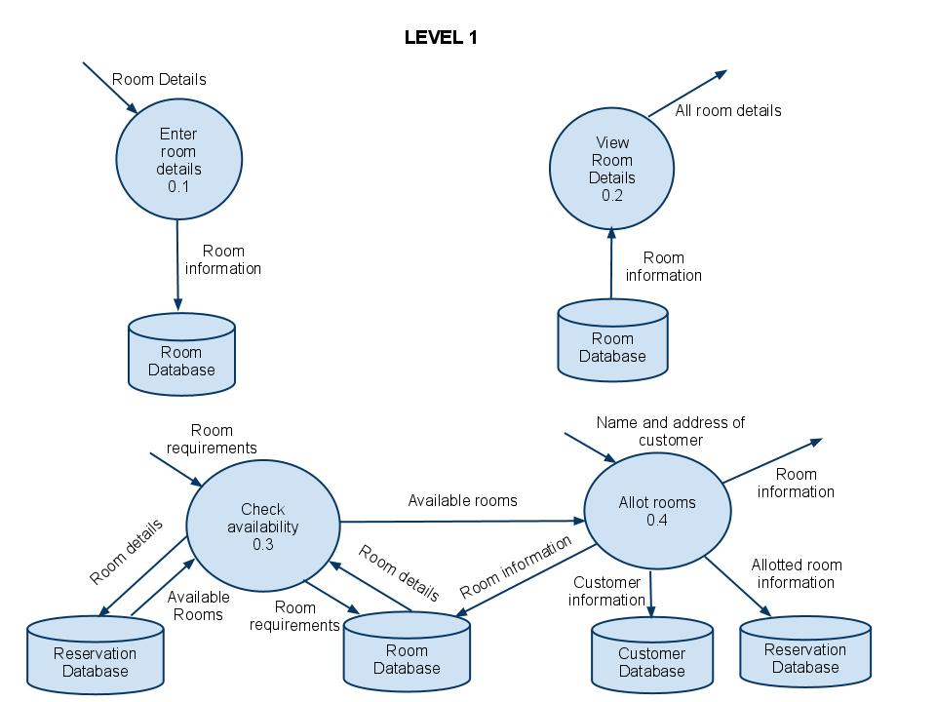

The Level 1 of the Data Flow Diagram shows Context diagram broken down into four modules. The Enter room details module takes the new rooms available and updates the Room database. When a customer checks out of the hotel the vacant room is again added to the room database. The View Room Details takes all the rooms present in the Room database and displays it for the hotel manager. The Check availability module takes the room requirements given by the customer and searches in the database whether such rooms are presents. If such rooms exist then it checks whether the rooms are available. If the rooms are available then it passes the room numbers to the Allot Rooms module which takes the name and address from the customer and stores it in the customer database and makes an entry in the reservation database. It also allots the room to the customer. If the rooms are not available the customer is informed of it.

CODES
The Coding part comprises of designing ‘html web pages’ and writing appropriate codes to serve the purpose. For each of the designed web pages we have a java servlet file written which include the code to connect with the database and serve the purpose of the web page. The database used here is Oracle. The code snippets of the designed web pages are given as follows.
Index Page:
The figure below shows the index page of the ABC Hotel Reservation System. This page contains only simple HTML tags and has kinks to the following pages.
- Customer Enquiry
- View Room List
- View Reservation List
- Add Room Information
- Check-Out Customer

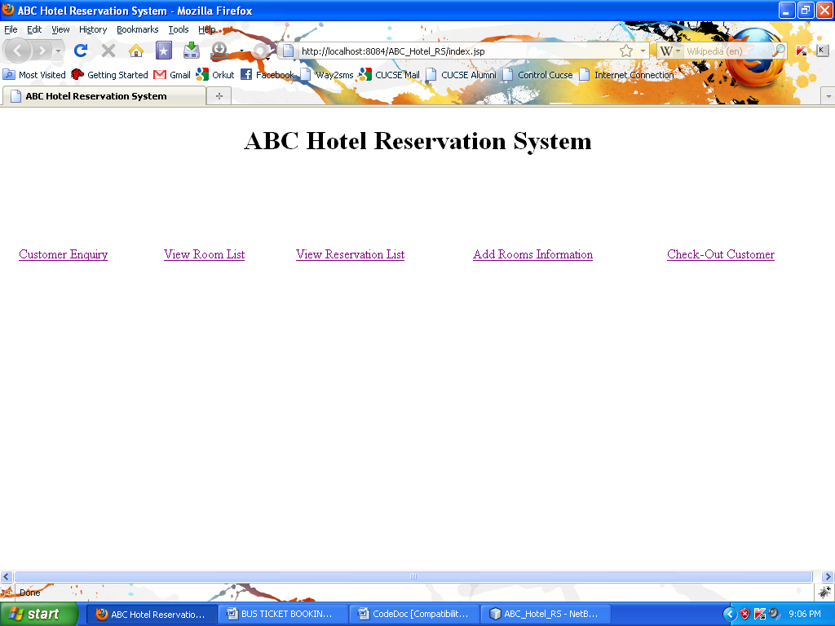
Figure 1: The Main index page

Customer Enquiry:
The figure below is of CustEnquiry.jsp which is a simple HTML page containing the options that any normal customer would require to specify to know whether the kind of room that they are wanting is available or not. In other words when the customer fills in the above form and submits it, the customer gets to see all the available rooms with the specifications mentioned by him.
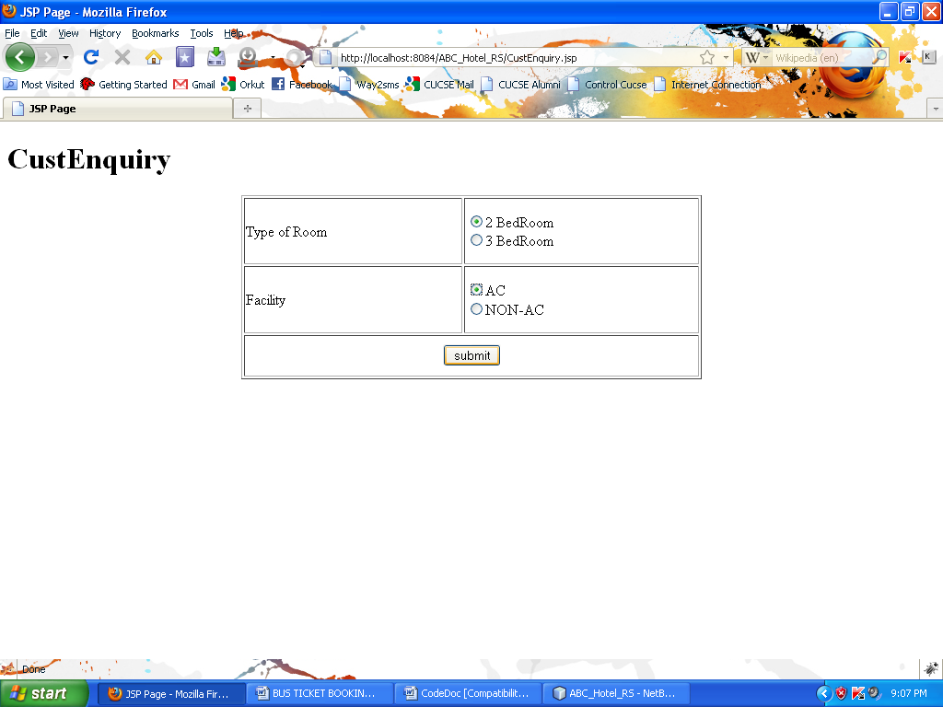
Figure 2: Customer Enquiry Page

Code Snippets:
Below is the code behind the ‘Submit’ Button. When ‘Submit’ button is pressed the following code is triggered to show the availability information.
First we make a connection with the database using the following code:
Class.forName ("com.mysql.jdbc.Driver");
con=DriverManager.getConnection("jdbc:mysql://localhost:3306/DBName","Root","Password”);
Next we create a statement object as follows:
stmt = con.createStatement();
Next we execute the query which is supposed to perform the task of inserting a record into the database
String s="select * from rooms where AC_NONAC=" + AC_NONAC + "and NO_OF_BEDS=" + NO_OF_BEDS + "and RESERVED=0";
This statement takes the required input from the corresponding text fields and completes the statement which is then executed as a complete query.This query selects all the room records that’s matches the users specifications.
Now we run the query and obtain the result in a record set called ‘records’
records =s1.executeQuery(s);
Now we loop through the record set and display the results in suitable format:
while (records.next())
{
s3=records.getString("AC_NONAC");
s4=records.getString("RESERVED");

if(s3.equals("4"))
{
s3="AC";
}
else
{
s3="NON-AC";
}

if(s4.equals("0"))
{
s4="NO";
}
else
{
s4="YES";
}

out.println("<tr>");
out.println("<td>"+records.getString("ROOM_NO")+"</td><td>" + s3 +"</td><td>"+records.getString("NO_OF_BEDS")+"</td><td>"+ s4 + "</td>");
out.println("</tr>");
}

Customer Enquiry Results and Reservation:
The figure below is the output of the SearchRoomServlet servlet which finds all the rooms available with the specifications given by the user.
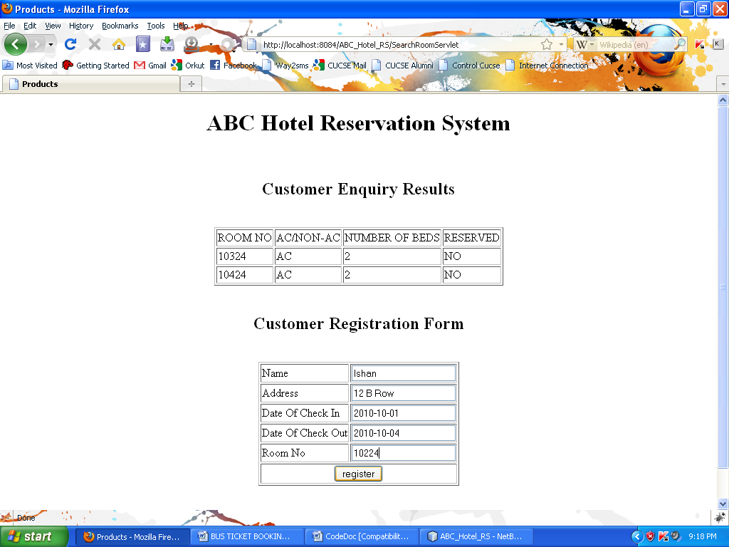
Figure 3: Customer Enquiry Results page

Code Snippets:
Below is the code behind the ‘register’ Button. When ‘register’ button is pressed the following code is triggered in the servlet named ReservationServlet.java to perform a customer registration.
First we make a connection with the database using the following code:
Class.forName ("com.mysql.jdbc.Driver");
con=DriverManager.getConnection("jdbc:mysql://localhost:3306/DBName","Root","Password”);
These statements takes the required input from the corresponding text fields and completes the statement which is then executed as a complete query :
String Cname = request.getParameter("Cname").toString();
String CINDate = request.getParameter("CINDate").toString();
String COUTDate = request.getParameter("COUTDate").toString();
String RoomNo = request.getParameter("RoomNo").toString();
String Add = request.getParameter("Add").toString();
String RS_ID = Cname + RoomNo ;
String CUST_ID = Cname + RoomNo ;

Next we create a statement object as follows:
stmt = con.createStatement();
Next we execute the query which is supposed to perform the task of inserting a record into the database
String s="insert into RESERVATION values('" + RS_ID + "','" + CINDate + "','" + COUTDate + "','" + RoomNo + "')";
String S1=" insert into CUSTOMER values ('" + CUST_ID + "','" + Cname + "','" + Add + "','" + RS_ID + "')";
String S2="Update Rooms SET RESERVED=1 where ROOM_NO='" + RoomNo +"'";

These above queries inserts values and updates tables Reservation,Customer and Rooms respectively.

Now we run the queries to insert the values in the requisite tables and update tables.
n=s1.executeUpdate(s);
n=s1.executeUpdate(S1);
n=s1.executeUpdate(S2);

A suitable Output page is provided :
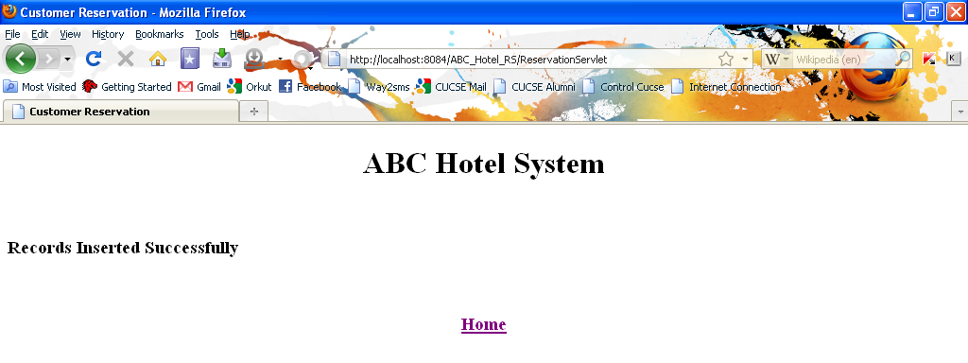
Figure 4: Insertion Confirmation Page

View Room:
The figure below shows the View Room List page. When the hotel manager clicks the ‘View Room’ button the list of all rooms are shown.
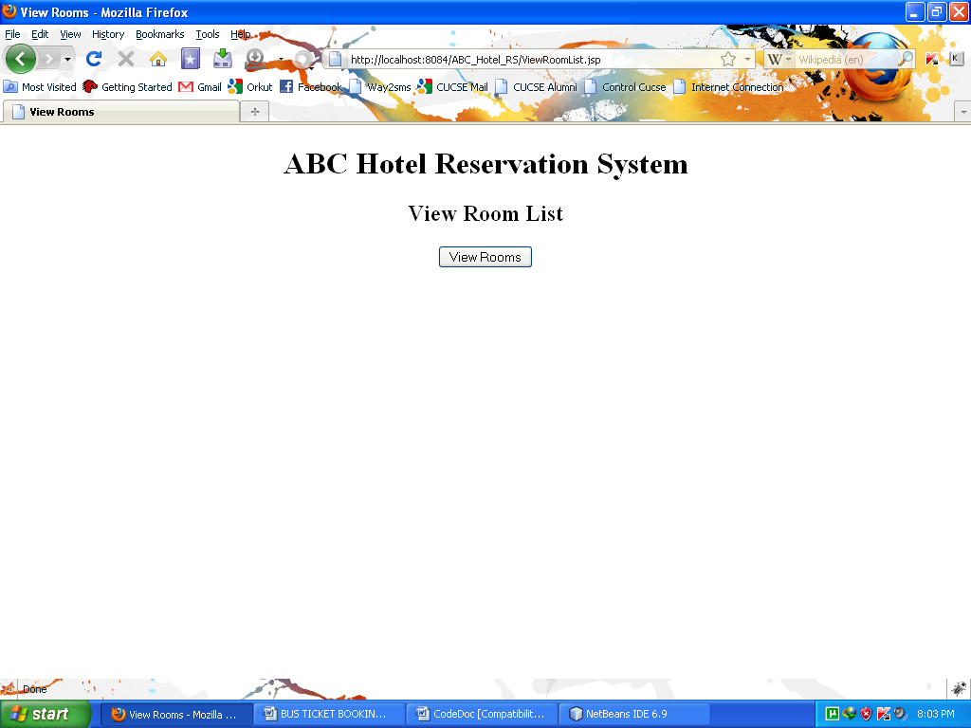
Figure 5: View Room List Page

Code Snippets:
Below is the code behind the ‘View Rooms’ Button. When ‘View Rooms’ button is pressed the following code is triggered in the servlet named ViewRoomServlet.java to perform a room lookup.
First we make a connection with the database using the following code:
Class.forName ("com.mysql.jdbc.Driver");
con=DriverManager.getConnection("jdbc:mysql://localhost:3306/DBName","Root","Password”);
Next we create a statement object as follows:
stmt = con.createStatement();
This query selects all the room records that are in the Room table in the database.
String s="select * from rooms";
Now we run the query and obtain the result in a record set called ‘records’
records =s1.executeQuery(s);
Now we loop through the record set and display the results in suitable format:
while (records.next())
{

s3=records.getString("AC_NONAC");
s4=records.getString("RESERVED");

if(s3.equals("4"))
{
s3="AC";
}
else
{
s3="NON-AC";
}

if(s4.equals("0"))
{
s4="NO";
}
else
{
s4="YES";
}

out.println("<tr>");
out.println("<td>"+records.getString("ROOM_NO")+"</td><td>" + s3 +"</td><td>"+records.getString("NO_OF_BEDS")+"</td><td>"+ s4 + "</td>");
out.println("</tr>");
}

The above records are presented in a HTML page in form of a table, as shown in the Figure 6
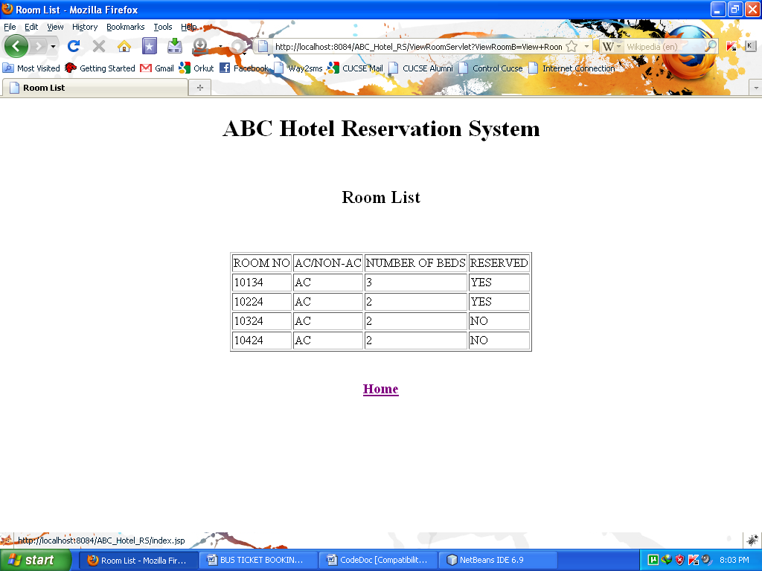
Figure 6: Room List Page
View Reservation:
The figure below shows the View Reservation page. When the hotel manager clicks the ‘Vire Reservation List ‘ button the list of all the customers currently staking or has reserved rooms in the hotel are shown.
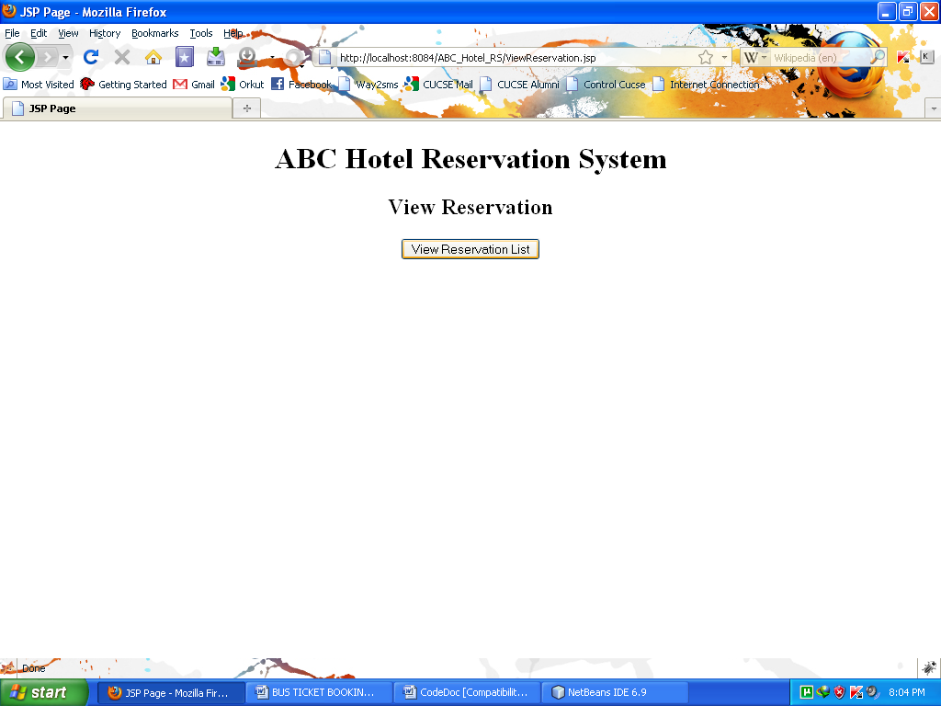
Figure 7: View Reservation Page

Code Snippets:
Below is the code behind the ‘View Reservation List’ Button. When ‘View Reservation List’ button is pressed the following code is triggered in the servlet named ViewReservationListServlet.java to perform a reservation lookup.
First we make a connection with the database using the following code:
Class.forName ("com.mysql.jdbc.Driver");
con=DriverManager.getConnection("jdbc:mysql://localhost:3306/DBName","Root","Password”);
Next we create a statement object as follows:
stmt = con.createStatement();
This query selects all the room records that are in the Room table in the database.
String s="Select CUST_ID,NAME,ADDRESS, RESERVATION.RS_ID as RSV_ID,DT_OF_CHECKIN,DT_OF_CHECKOUT,ROOM_NO from CUSTOMER,App.RESERVATION where CUSTOMER.RS_ID= RESERVATION.RS_ID";
Now we run the query and obtain the result in a record set called ‘records’
records =s1.executeQuery(s);
Now we loop through the record set and display the results in suitable format:
while (records.next())
{

out.println("<tr>");
out.println("<td>"+records.getString("CUST_ID")+"</td><td>" + records.getString("NAME") +"</td><td>"+ records.getString("ADDRESS") +"</td><td>"+ records.getString("RSV_ID")+"</td><td>"+records.getString("DT_OF_CHECKIN")+ "</td><td>"+records.getString("DT_OF_CHECKOUT")+"</td><td>" + records.getString("ROOM_NO")+"</td>");
out.println("</tr>");
}

The above records are presented in a HTML page in form of a table, as shown in the Figure 8
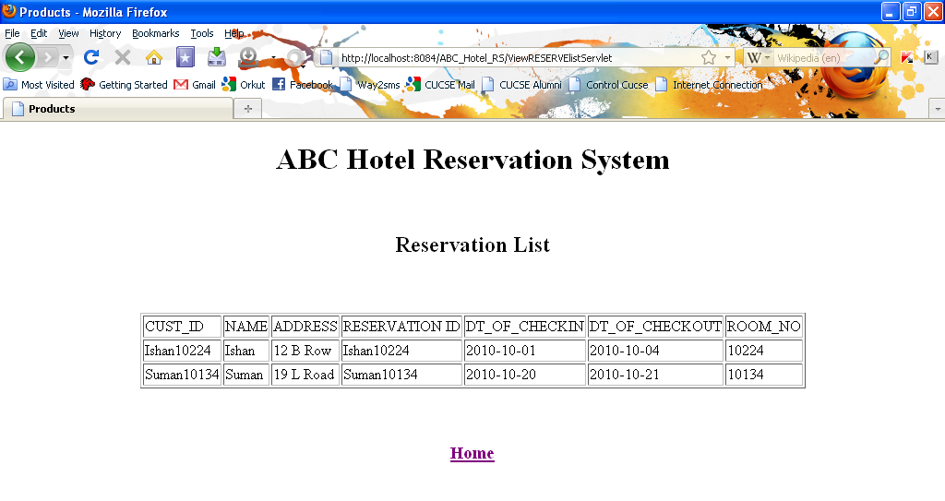
Figure 8: View Reservation List Page
Add Room:
The figure below shows the add room page. In this page the hotel manager can add rooms to the room list. For example when all the rooms are reserved the hotel manager can add rooms to the room list from the hand full of rooms that are not given to customers when not needed.
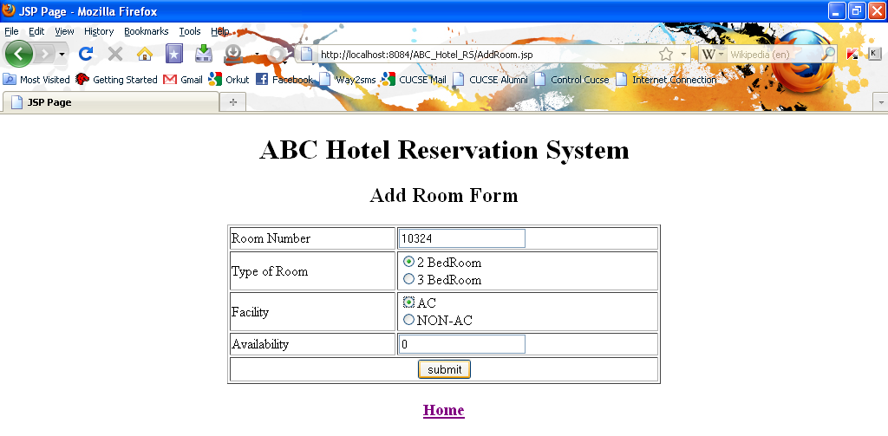
Figure 9 Add Room page

Code Snippets:
Below is the code behind the ‘Submit’ Button. When ‘Submit’ button is pressed the following code is triggered in the servlet named AddRoomServlet.java to perform room increment operation.
First we make a connection with the database using the following code:
Class.forName ("com.mysql.jdbc.Driver");
con=DriverManager.getConnection("jdbc:mysql://localhost:3306/DBName","Root","Password”);
These statements takes the required input from the corresponding text fields and completes the statement which is then executed as a complete query :
String RoomNo= request.getParameter("RoomNo").toString();
String BedType = request.getParameter("bed").toString();
String Facility = request.getParameter("facility").toString();
String Avail= request.getParameter("Avail").toString();
RoomNo = RoomNo + BedType + Facility ;

Next we create a statement object as follows:
stmt = con.createStatement();
Next we execute the query which is supposed to perform the task of inserting a record into the database
String s="insert into Rooms values('" + RoomNo + "'," + Facility + "," + BedType + "," + Avail + ")";
These above query inserts values into table Rooms.

Now we run the queries to insert the values in the requisite tables and update tables.
n=s1.executeUpdate(s);

Check Out Customer:
In the page below the hotel manager can check-out a customer form the hotel.
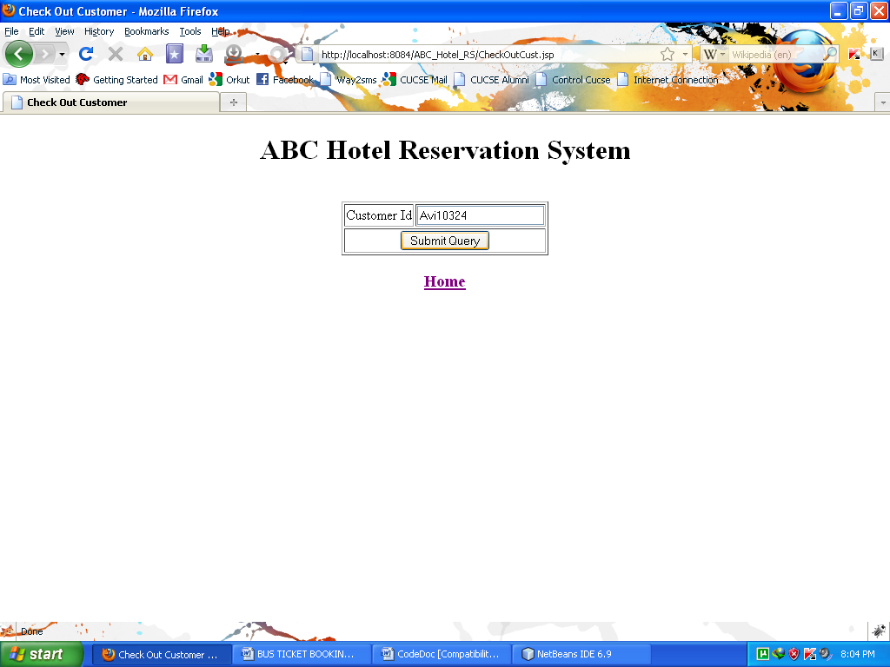
Figure 10: Check-Out Customer Page

Code Snippets:
Below is the code behind the ‘Submit’ Button. When ‘Submit’ button is pressed the following code is triggered in the servlet named CheckOutServlet.java to perform check-outoperation.
First we make a connection with the database using the following code:
Class.forName ("com.mysql.jdbc.Driver");
con=DriverManager.getConnection("jdbc:mysql://localhost:3306/DBName","Root","Password”);
These statements takes the required input from the corresponding text fields and completes the statement which is then executed as a complete query :
String CustId = request.getParameter("CustId").toString();
Next we create a statement object as follows:
stmt = con.createStatement();
Next we execute the query which is supposed to perform the task of finding out the room_No of the respective user_Id the hotel manager entered from the database
String S3="select Room_No from Reservation where RS_ID='" + CustId + "'";
Now we run the query and obtain the result in a record set called ‘records’
records=s1.executeQuery(S3);
Now we loop through the record set and display the results in suitable format:
while (records.next())
{
RoomNo= records.getString("Room_No");
}
Again we create queries to delete the record of the particular customer from the Customer table, Reservation table and update the availability status of the room he was staying in as Available.

String s="delete from customer where CUST_ID='" + CustId + "'"
String S1="delete from reservation where RS_ID='" + CustId + "'";
String S2="Update Rooms SET RESERVED=0 where ROOM_NO='" + RoomNo +"'";

We execute the queries to do the above tasks.

n=s1.executeUpdate(s);
n=s1.executeUpdate(S1);
n=s1.executeUpdate(S2);

Conclusion
In this case study we have considered a Hotel Reservation system, which is managed by the hotel manager. All the modules in this case study is operated upon by the hotel manager. Starting from jobs like taking requests from the customer and let them know if any room according to the users specifications are available, the hotel manager can reserve rooms for any customer. Apart from that the manager can see the list of all the rooms, the reservation list of the hotel, he can add extra rooms for reservation in peak season and at last but not the least check-out a customer from the hotel. In other words this case study covers the overall basic functionalities of a typical hotel management system in the form of a Software Solution.

